Batch: B2 Roll No.: 16010121200

Experiment No. 02

Grade: AA / AB / BB / BC / CC / CD /DD

Signature of the Staff In-charge with date

TITLE: Shell Programming and system calls
_____________________________________________________________________

AIM: To study the shell script and write the program using shell.
______________________________________________________________________
Expected Outcome of Experiment:

CO 1. To introduce basic concepts and functions of operating systems.
_____________________________________________________________________
Books/ Journals/ Websites referred:

- Silberschatz A., Galvin P., Gagne G. “Operating Systems Principles”, Willey Eight edition.
- William Stallings “Operating Systems” Person, Seventh Edition
Edition.
- Sumitabha Das “ UNIX Concepts & Applications”, McGraw Hill Second
Edition.
_____________________________________________________________________
Pre Lab/ Prior Concepts:

The shell provides you with an interface to the UNIX system. It gathers input from you and executes programs based on that input. When a program finishes executing, it displays that program's output.

Shell Scripts
The basic concept of a shell script is a list of commands, which are listed in the order of execution. A good shell script will have comments, preceded by a pound sign, #, describing the steps.
Steps to create a Shell Script:
create a file using any text editor say vi, gedit, nano etc
1.$ vi filename
2.Insert the script/ commands in file and save the file to execute the file we need to give execute permission to the file
3.$ chmod 775 filename
4.Now execute the above file using any of following methods:
$ sh filename
OR
$ ./filename

NOTE: Before adding anything to your script, you need to alert the system that a shell script is being started. This is done using the shebang construct. For example −
#!/bin/sh.
______________________________________________________________________
Description of the application to be implemented:
- Write a shell Script that accepts two file names as command line arguments and compare two file contents and check whether contents are same or not. If they are same, then delete second file.

- Write a shell script that accepts integer and find the factorial of the number.

- Write a shell script for adding users.

- Write a shell script for counting no of logged in users.

- Write a shell script for counting no of processes running on system

Program for System Call:
- Write a Program for creating process using System call (E.g fork()) Create a child process. Display the details about that process using getpid and getppid functions. In a child process, Open the file using file system calls and read the contents and display.

Implementation details: (printout of code / screen shot)
- Write a shell Script that accepts two file names as command line arguments and compare two file contents and check whether contents are same or not. If they are same, then delete second file.
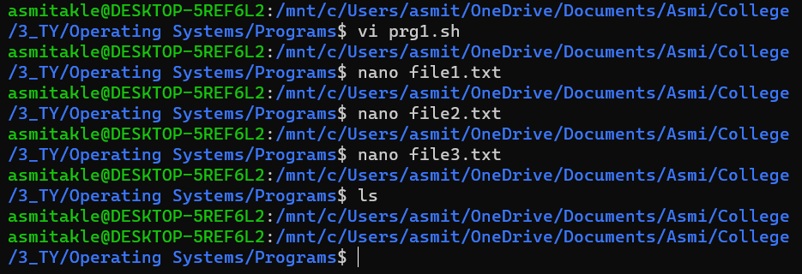
prg1.sh
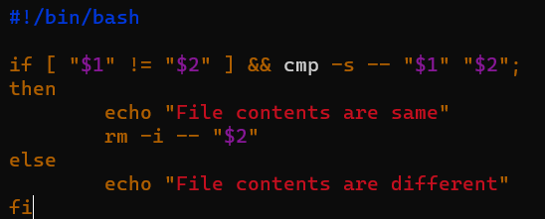
file1.txt: Hello World!
file2.txt: Hello World!
file3.txt: Goodbye World!

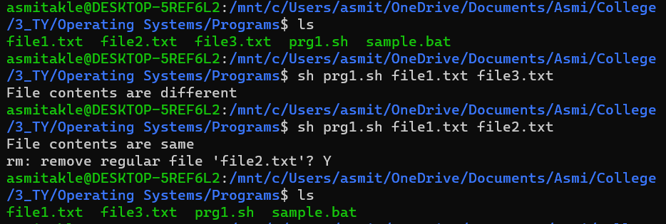

- Write a shell script that accepts integer and find the factorial of the number.

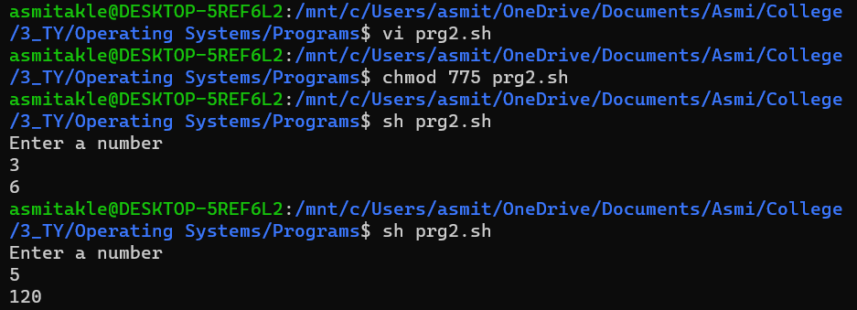
prg2.sh

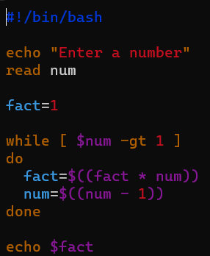

- Write a shell script for adding users.

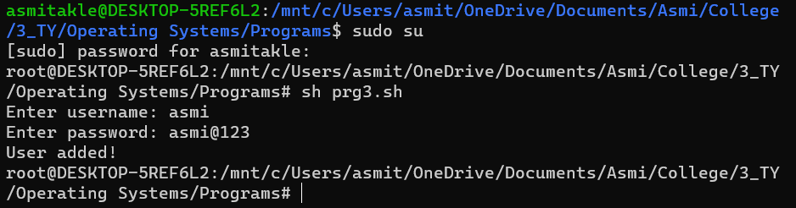

prg3.sh

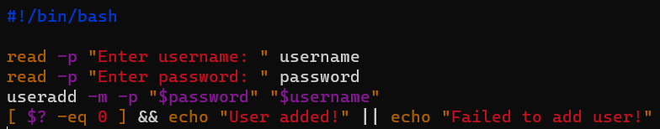

- Write a shell script for counting no of logged in users.
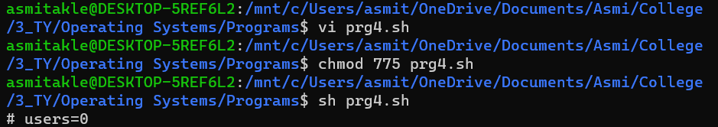

prg4.sh

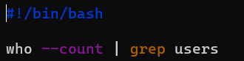

- Write a shell script for counting no of processes running on system

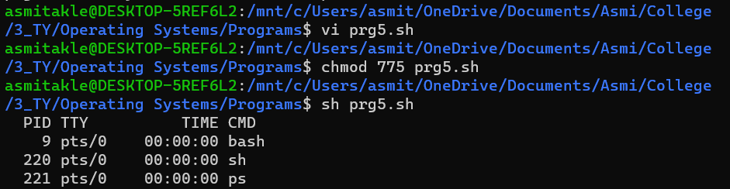

prg5.sh

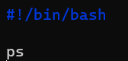

System Call Program:
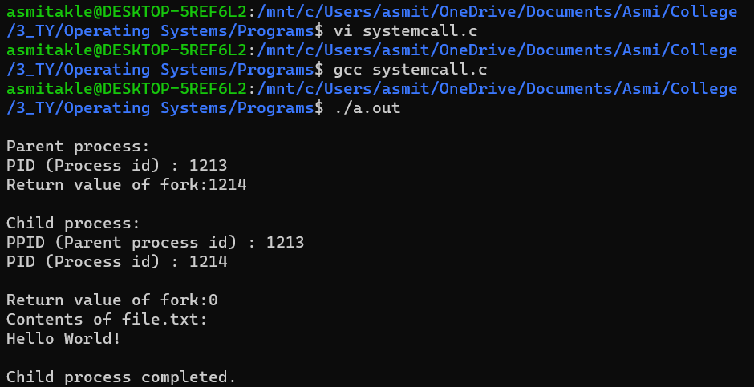

systemcall.c
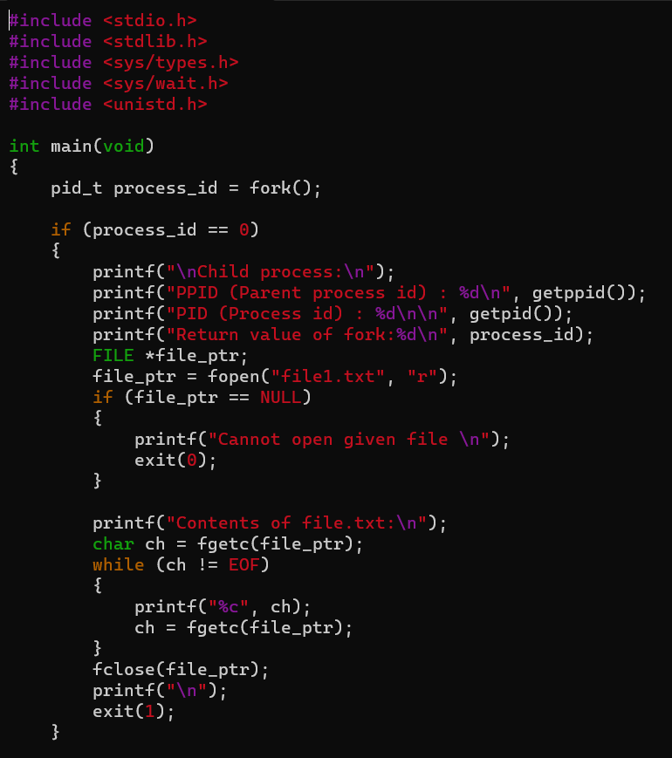
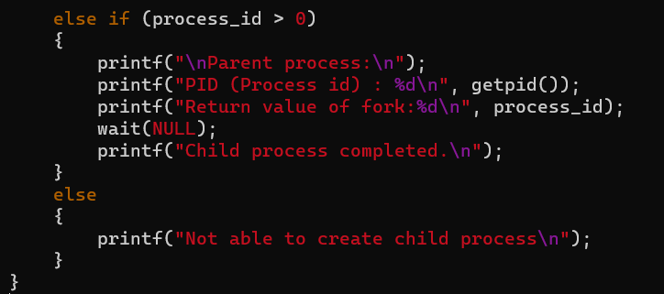
Conclusion:
Studied and explored the shell script and implemented programs and system calls.

Post Lab Descriptive Questions

- What are the different types of commonly used shells on a typical linux system?

Bourne Shell (sh)
Developed at AT&amp;T Bell Labs by Steve Bourne, the Bourne shell is regarded as the first UNIX shell ever. It is denoted as sh. It gained popularity due to itscompact nature and high speeds of operation.

However, the Bourne shell has some major drawbacks.
It doesn’t have in-built functionality to handle logical and arithmetic operations.
Also, unlike most different types of shells in Linux, the Bourne shell cannot recall previously used commands.
It also lacks comprehensive features to offer a proper interactive use.
The complete path-name for the Bourne shell is /bin/sh and /sbin/sh. By
default, it uses the prompt # for the root user and $ for the non-root users.

GNU Bourne-Again Shell (bash)
More popularly known as the Bash shell, the GNU Bourne-Again shell was
designed to be compatible with the Bourne shell. It incorporates useful
features from different types of shells in Linux such as Korn shell and C
shell.
It allows us to automatically recall previously used commands and edit them
with help of arrow keys, unlike the Bourne shell.
The complete path-name for the GNU Bourne-Again shell is /bin/bash. By
default, it uses the prompt bash-VersionNumber# for the root user and
bashVersionNumber$ for the non-root users.

C Shell (csh)
The C shell was created at the University of California by Bill Joy. It is
denoted as csh. It was developed to include useful programming features
like in-built support for arithmetic operations and a syntax similar to the C
programming language.
Further, it incorporated command history which was missing in different
types of shells in Linux like the Bourne shell. Another prominent feature of
a C shell is “aliases”.
The complete path-name for the C shell is /bin/csh. By default, it uses the
prompt hostname# for the root user and hostname% for the non-root users.

Korn Shell (ksh)
The Korn shell was developed at AT&T Bell Labs by David Korn, to
improve the Bourne shell. It is denoted as ksh. The Korn shell is essentially
a superset of the Bourne shell.
Besides supporting everything that would be supported by the Bourne shell,
it provides users with new functionalities. It allows in-built support for
arithmetic operations while offereing interactive features which are similar
to the C shell.
The Korn shell runs scripts made for the Bourne shell, while offering string,
array and function manipulation similar to the C programming language. It
also supports scripts which were written for the C shell. Further, it is faster
than most different types of shells in Linux, including the C shell.
The complete path-name for the Korn shell is /bin/ksh. By default, it uses the
prompt # for the root user and $ for the non-root users.

Z Shell (zsh)
The Z Shell or zsh is a sh shell extension with tons of improvements for
customization.

- How do you find out what is your shell?

1. The echo command in Linux is used to display a line of text or string that is passed to it as an argument. We can also use this command to print the current shell.
$ echo $SHELL
/bin/bash
2. The ps (process status) command provides a snapshot of the currently running processes:
$ ps
PID TTY TIME CMD
4467 pts/0 00:00:00 bash
5379 pts/0 00:00:00 ps
The last column CMD in the output shows that the bash shell is currently running.

- List the advantages and disadvantages of shell scripting.

Advantages of shell scripts

- The command and syntax are exactly the same as those directly entered in command line, so programmer do not need to switch to entirely different syntax
- Writing shell scripts are much quicker
- Quick start
- Interactive debugging etc.

Disadvantages of shell scripts

- Prone to costly errors, a single mistake can change the command which might be harmful
- Slow execution speed
- Design flaws within the language syntax or implementation
- Not well suited for large and complex task
- Provide minimal data structure unlike other scripting languages. etc

Date: _____________ Signature of faculty in-charge

